DNSSEC (Domain Name System Security Extensions)
Audience: AWS Security Specialty
DNSSEC is an extension to DNS (Domain Name System) that adds security features to prevent attackers from tampering with DNS responses.
Normally, DNS translates a domain name (like www.example.com) into an IP address (like 203.0.113.10). But traditional DNS has no security — it trusts any response it gets, making it vulnerable to attacks like DNS spoofing or cache poisoning.
DNSSEC fixes this by using digital signatures and cryptographic keys. It ensures that when your system gets a DNS response, it can verify:
- Authenticity – the response really came from the correct DNS server.
- Integrity – the response was not modified in transit.
Why is DNSSEC Important?
Without DNSSEC, attackers can perform a man-in-the-middle attack by injecting fake DNS responses.
- Example: You type www.yourbank.com, but an attacker tricks DNS to return the IP of a fake phishing website.
- You think you’re on your bank’s website, but you’re actually giving your login details to the attacker.
With DNSSEC, your computer verifies the DNS response using digital signatures. If the response is altered or fake, your system rejects it.
Scenario / Example
Without DNSSEC:
- A user wants to visit www.securebank.com.
- The attacker launches a DNS cache poisoning attack on the ISP’s DNS resolver.
- The DNS resolver now replies:
  - www.securebank.com → 198.51.100.50 (attacker’s phishing site).
- User gets redirected to a fake banking website that looks real and enters their username & password.
- Credentials are stolen.
With DNSSEC:
- The attacker still tries to inject a fake DNS record.
- But DNSSEC requires that DNS responses come with a digital signature (RRSIG).
In DNSSEC, RRSIG stands for Resource Record Signature. It's a DNS record type that contains a digital signature used to authenticate the data within a corresponding set of DNS resource records (RRset). This signature is created using a private key and can be verified by resolvers using the corresponding public key stored in a DNSKEY record.
- The resolver checks the public key (DNSKEY) in the authoritative zone and verifies the signature.
- Since the attacker can’t forge the correct signature, the fake record fails validation.
- User only gets the real IP address of www.securebank.com.
Key Benefits of DNSSEC
- Protects against DNS spoofing & cache poisoning.
- Ensures trustworthy DNS responses.
- Provides data integrity in DNS communication.
- Builds the foundation for advanced security protocols like DANE (DNS-based Authentication of Named Entities).

Agenda
- Introduction to DNS and its Weakness (10 min)
- What is DNSSEC? (10 min)
- How DNSSEC Works – Deep Dive (15 min)
- Scenarios & Real-World Examples (10 min)
- Importance of DNSSEC in Security (5 min)
- DNSSEC in AWS – Implementation & Use Cases (10 min)

1. Introduction to DNS and Its Weakness (10 min)
- What is DNS?
  - DNS = "Phonebook of the Internet".
  - Converts domain names (e.g., www.example.com) into IP addresses (e.g., 192.168.1.10).
- Problem with Traditional DNS
  - DNS is old (1980s design), built for scalability, not for security.
  - DNS queries & responses are unencrypted and unauthenticated.
- DNS Attacks Possible Without Security
  - DNS Spoofing / Cache Poisoning: Attacker injects fake records into DNS cache.
  - Man-in-the-Middle (MITM): Attacker intercepts DNS queries and provides fake answers.
  - Amplification Attacks: Used for DDoS.
Layman Analogy:
Imagine asking a friend for a restaurant’s address. If someone else gives you the wrong address, you end up at a scam shop. That’s DNS spoofing.
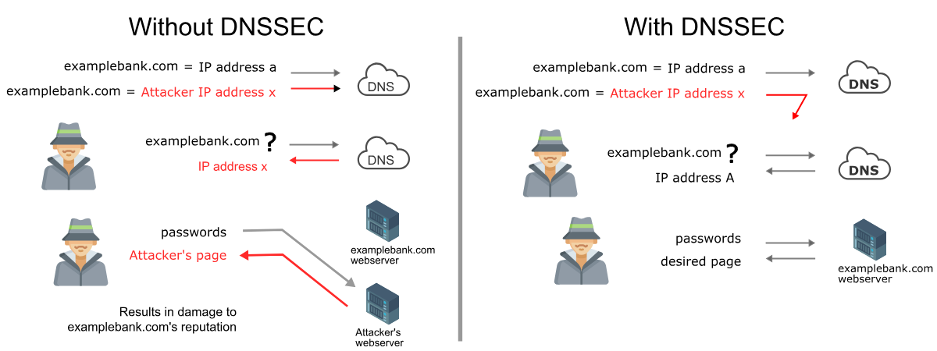

2. What is DNSSEC? (10 min)
- DNSSEC (Domain Name System Security Extensions) is a set of extensions that:
  - Adds digital signatures to DNS data.
  - Ensures data is authentic and not tampered.
  - Provides data integrity + origin authentication, but not confidentiality.
- Key Concept:
  - Each DNS zone (like .com, example.com) has a public/private key pair.
  - Private key = used by the zone owner to sign records.
  - Public key = published so resolvers can verify authenticity.
Layman Analogy:
It’s like receiving a sealed envelope with a signature from the restaurant itself. You can check the seal to confirm the address hasn’t been modified.

3. How DNSSEC Works – Deep Dive (15 min)
- Steps in DNSSEC Validation:
  - Query: A user asks DNS resolver: “What’s the IP for example.com?”
  - DNS Response with Signatures: The authoritative DNS server replies with the answer + digital signature (RRSIG record).
  - Resolver Verification: The DNS resolver verifies the signature using the public key (DNSKEY record).
  - Chain of Trust:
    - .com verifies example.com.
    - . (root) verifies .com.
    - Root zone is the trust anchor.
- Important DNSSEC Records:
  - RRSIG – Holds the digital signature for a record.
  - DNSKEY – Contains the public key.
  - DS (Delegation Signer) – Links a child zone to parent zone (chain of trust).
  - NSEC / NSEC3 – Provides proof of non-existence (no fake NXDOMAIN).

4. Scenarios & Real-World Examples (10 min)
Scenario 1: Banking Website
- Without DNSSEC:
  - Attacker spoofs DNS for bank.com → user lands on fake site → credentials stolen.
- With DNSSEC:
  - Resolver rejects fake DNS because the signature doesn’t match.
Scenario 2: Free Wi-Fi in Cafe
- Without DNSSEC:
  - Attacker intercepts DNS queries → redirects facebook.com to malicious site.
- With DNSSEC:
  - Resolver verifies signature, detects mismatch → drops response.
Scenario 3: Corporate AWS VPC with Private Hosted Zones
- DNSSEC ensures that internal DNS queries to hosted zones (like internal.example.com) cannot be spoofed.
Takeaway: DNSSEC prevents fake answers and ensures that users always land on the real destination.

5. Importance of DNSSEC (5 min)
- Protects against DNS spoofing & cache poisoning.
- Ensures integrity of DNS responses.
- Strengthens trust on the Internet.
- Mandatory for sensitive industries (banking, e-commerce, healthcare).
- Complements TLS/SSL (DNSSEC secures DNS, TLS secures traffic).
Note: DNSSEC does not encrypt DNS queries → that’s the job of DoH/DoT.

6. DNSSEC in AWS – Implementation & Use Cases (10 min)
AWS Route 53 Support
- Route 53 supports DNSSEC signing and DNSSEC validation.
- Two parts in AWS:
  - Signing: For Route 53 public hosted zones, you can enable DNSSEC signing. AWS manages key pairs & signatures.
  - Validation: If using Route 53 Resolver, DNSSEC validation can be turned on.
How to Enable DNSSEC in Route 53
- Go to Route 53 Console → Hosted Zones.
- Choose the hosted zone → Enable DNSSEC signing.
- AWS generates keys automatically.
- Add a DS record in your domain registrar to establish the chain of trust.
- Test using dig +dnssec example.com or online tools.
- Or Test using https://dnssec-debugger.verisignlabs.com/ url.
AWS Use Cases
- Banking app on AWS: Protect DNS resolution for customer domains.
- Multi-account VPC setup: Internal DNS queries secured.
- Hybrid Cloud: Ensure DNS queries between on-prem & AWS are authentic.

Recap (2–3 min)
- DNS is insecure by default → vulnerable to spoofing.
- DNSSEC adds digital signatures & chain of trust.
- Key records: RRSIG, DNSKEY, DS, NSEC.
- AWS Route 53 supports DNSSEC → easy to enable.
- Essential for security-sensitive applications.

Time Allocation (60 min)
- DNS & Weakness: 10 min
- DNSSEC Concept: 10 min
- DNSSEC Working: 15 min
- Scenarios & Examples: 10 min
- Importance: 5 min
- AWS Implementation: 10 min

Lab: Configuring DNSSEC for a Route 53 Hosted Zone (sanjaycloud69.in)

Pre-requisites
- An active AWS account.
- A public hosted zone in Route 53 → sanjaycloud69.in.
- Access to your domain registrar (where you purchased sanjaycloud69.in) → you’ll need to update the DS (Delegation Signer) record there.

Step 1 – Enable DNSSEC Signing in Route 53
- Login to AWS Management Console → Go to Route 53.
- In the Navigation pane, choose Hosted zones.
- Select your hosted zone → sanjaycloud69.in.
- In the DNSSEC signing section → Click Enable DNSSEC signing.
- Choose Create a KSK (Key-Signing Key):
  - AWS will automatically create a KMS-managed KSK for you.
  - Keep the default options (recommended).
- Click Create.
Now your hosted zone is DNSSEC-enabled and signed by AWS.

Step 2 – Get the DS Record from Route 53
- After creating the KSK, go to Key-signing keys tab for the hosted zone.
- Select your KSK → Choose View DS record.
- You’ll see something like:
Key Tag: 12345
Algorithm: 13
Digest Type: 2
Digest: ABCDEF123456...
- Copy this DS record.

Step 3 – Add the DS Record at the Domain Registrar
- Log in to your domain registrar (where you purchased sanjaycloud69.in, e.g., GoDaddy, Namecheap, Route 53 Domains, etc.).
- Find the DNSSEC settings for your domain.
- Add the DS record values you copied from Route 53:
  - Key Tag
  - Algorithm
  - Digest Type
  - Digest
This step establishes the chain of trust between your registrar (parent zone .in) and your hosted zone (sanjaycloud69.in).

Step 4 – Verify DNSSEC
- Open a terminal and run:
dig +dnssec sanjaycloud69.in
  - You should see RRSIG (Resource Record Signature) records in the output.
- Alternatively, use online tools:
  - DNSViz
  - Verisign DNSSEC Debugger
If verification is successful → DNSSEC is active for sanjaycloud69.in.

Step 5 – (Optional) Enable DNSSEC Validation in Route 53 Resolver
- If you want clients inside your AWS VPCs to validate DNSSEC responses:
  - Go to Route 53 → Resolvers.
  - Create or edit a Resolver rule and enable DNSSEC validation.
  - Now your AWS environment will reject tampered DNS responses.

Cost of DNSSEC in AWS
- Route 53 Hosted Zone: $0.50 per hosted zone per month (already paying).
- DNS Queries: Same as before (no extra charge for DNSSEC).
- Key Signing (KMS):
  - Route 53 DNSSEC uses AWS KMS for storing cryptographic keys.
  - You pay KMS key cost:
    - $1/month per KSK (Key Signing Key).
    - API requests (very minimal, pennies).
Estimated Monthly Cost for DNSSEC on sanjaycloud69.in:
- Hosted Zone: $0.50
- KSK (1 key): $1.00
- Queries: Same as before (~$0.40 per million queries).
Total = ~$1.50 per month (plus existing query costs).

Recap for Students
- DNSSEC in Route 53 = Enable Signing + Publish DS record at Registrar.
- Verification = Check for RRSIG with dig +dnssec.
- Cost = About $1.50/month per hosted zone.
- Adds strong protection against DNS spoofing & cache poisoning.

